
Spring 2010  Unique Products  UNIQUE u·nique (adjective) [yoo neék] only one of a kind.  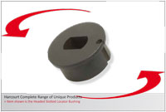  At Harcourt, our goal is to deliver quality products, on time, every time. Our range has been made even more complete with our unique products, which are now a part of our standard range. In doing this we offer you the peace of mind that whether the component is standard, or unique to Harcourt, you can consider it done.  Added to our product range is our ability to supply special items for you. Our experience and expertise in this field gives you the full package in Harcourt.  HARCOURT "your tooling component supplier for the 21st century"  Range of Unique Products  Listed below is a preview of some of the unique products that we have included in our complete range of products. One of the large benefits of this being included in our standard range is that we stock these items, making them available for immediate shipment.  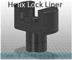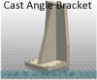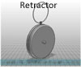  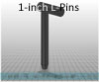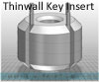  For ease of download and use in your designs, Harcourt models are minute in file size yet maintain realism and product functionality.  Standardize with Harcourt CAD  With models for our complete range of products available for configuration & download on our website, Harcourt can help you standardize in your design process. Our models are minute in file size & are available for every component in our range!  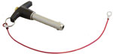  Included in our complete range are models for our Ball Lock Pins. These models are high quality, showing all details, yet still minute in size. Start standardizing today with our pins, & reduce your lead times & costs!  Custom Tool Storage Cases  Click here to view our cases online! 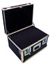 |  | Quick Links  - Our Website  - Your products portal  - Not recognized yet?  Featured Products  Tool Storage Cases  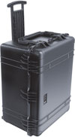  In response to your need of a smart, hardworking Tool Storage Case, Harcourt is pleased to announce the introduction of a comprehensive, complete range of cases. Available in hundreds of sizes, & for any application, you can now order custom sizes built to your specifications. For more information email us, or check us out online!  Handle Bushings  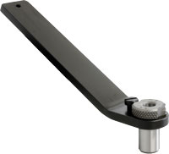  Our Handle Bushings are widely used to access holes that are difficult to reach with stationary or permanent tooling. With its removable bushings, you can use this heavy-duty handle for multiple operations. The lanyard hole allows you to efficiently & easily secure the handle. With your needs & requirements at top priority, we have specials & kits available. Click here to learn more about our Handle Bushings on our website!  Forward  Know someone who might be interested in this email? Please forward this email on.  Set-up  To access our products website you may need to need complete a user set-up form. Click here to complete this form.  View this on the web  To check out our news center on the web Click here.  Specials  Designing on something special? Need technical assistance? Email or call our ready sales staff today! Toll free: 800-888-5033.


Copyright 2009 Harcourt Industrial, Inc. All product names contained herein are the trademarks of their respective holders. Harcourt Industrial, Inc. is not responsible for the content or privacy of links to Web sites outside of the HARCOURT DESIGN NEWS. If you have any concerns about this email, its contents or how it is to be used, please read our Privacy Policy. To unsubscribe from HARCOURT DESIGN NEWS, email us at sales@harcourtind.com. Harcourt Industrial, Inc. | 1100 Whitcomb Ave. | Madison Heights, MI 48071 | 800-888-5033

